PIR Motion Detection System

program:

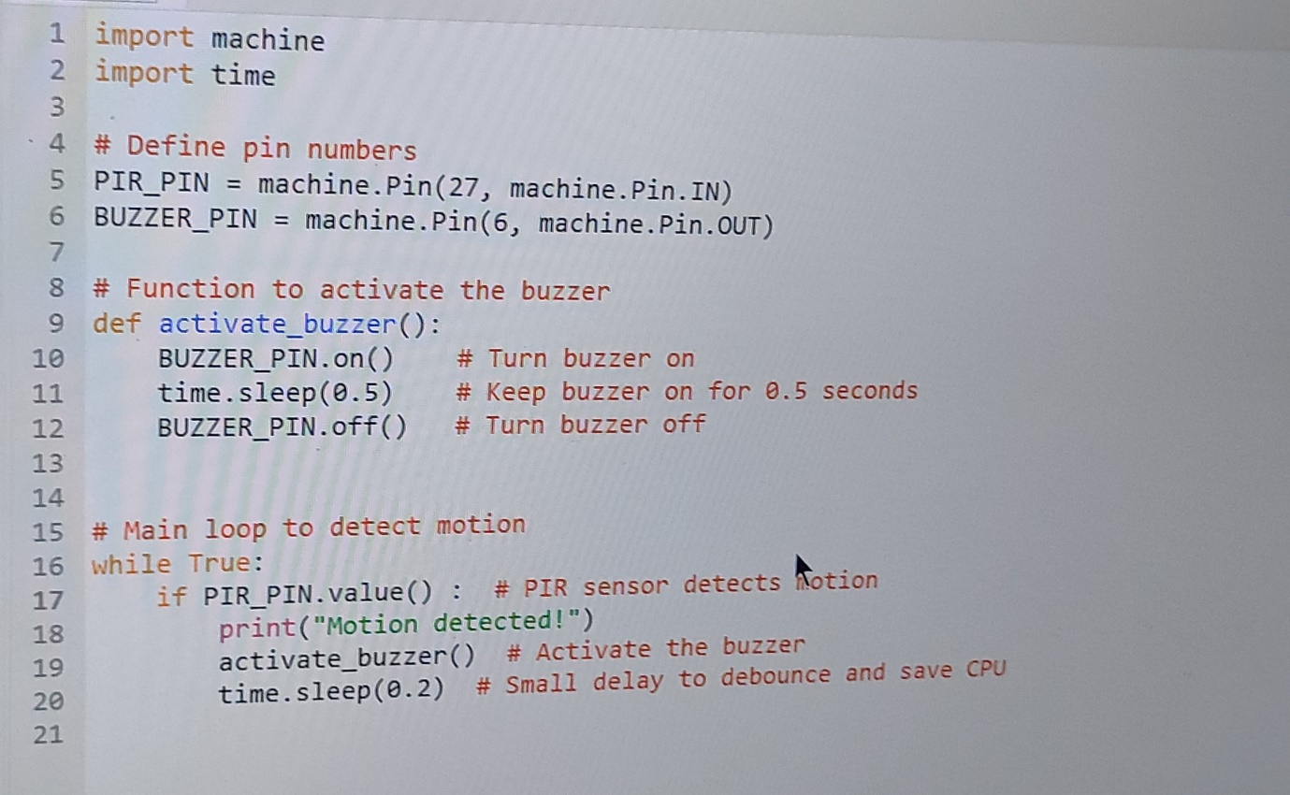

Output: 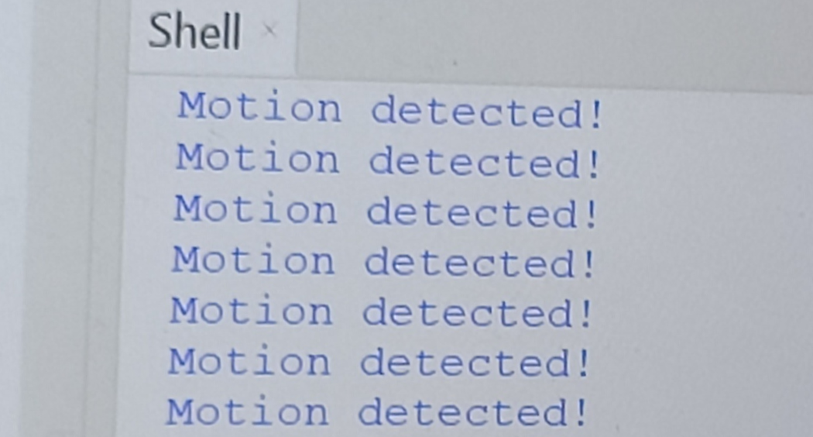

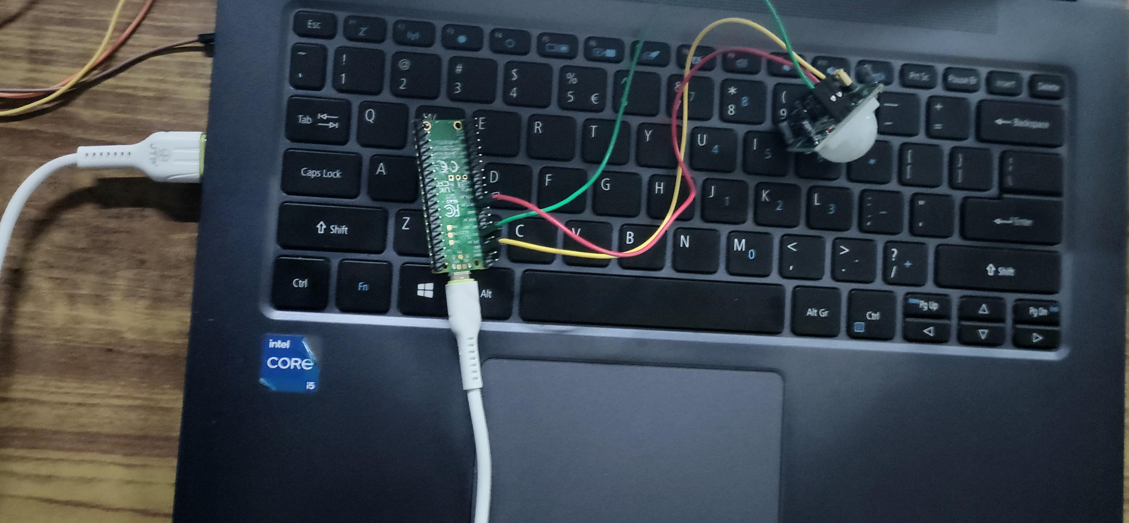

**N.Lohith Kumar (21781A04C7)**

**P.Sudharsan (21781A04E0)**

**P.Devanand (21781A04E8)**

**P.Reddy Shankar(21781A04F3)**

**P.Hemanth Reddy(21781A04F4)**